Model Exam

Develop a system using UML for BPO Management System. The system should hold the details of the customer and all approaches to it. It is managed by the central system.

Class Diagram

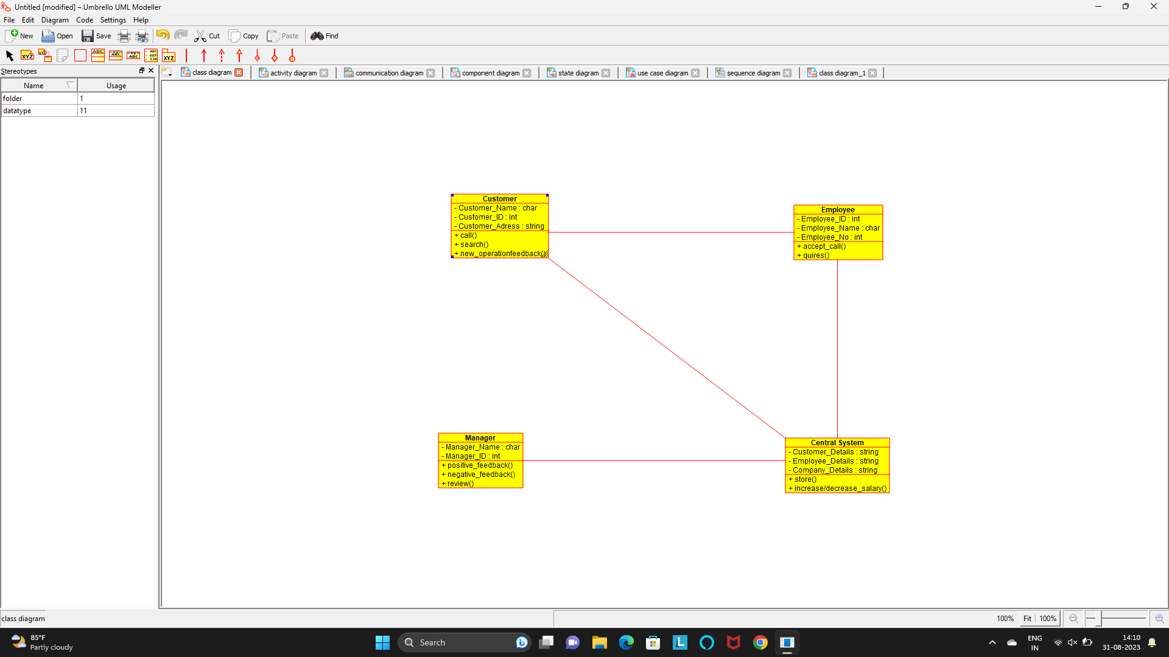

Activity Diagram

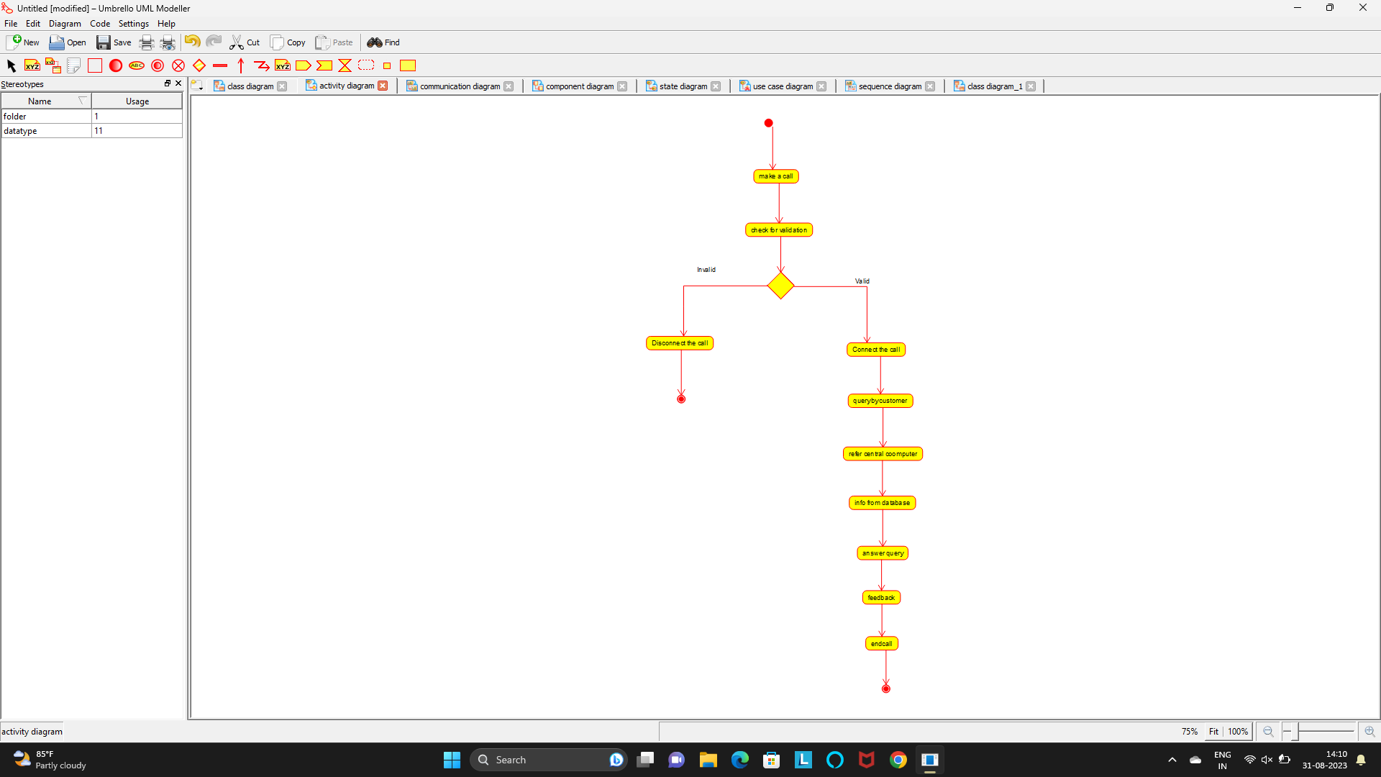

Collaboration Diagram

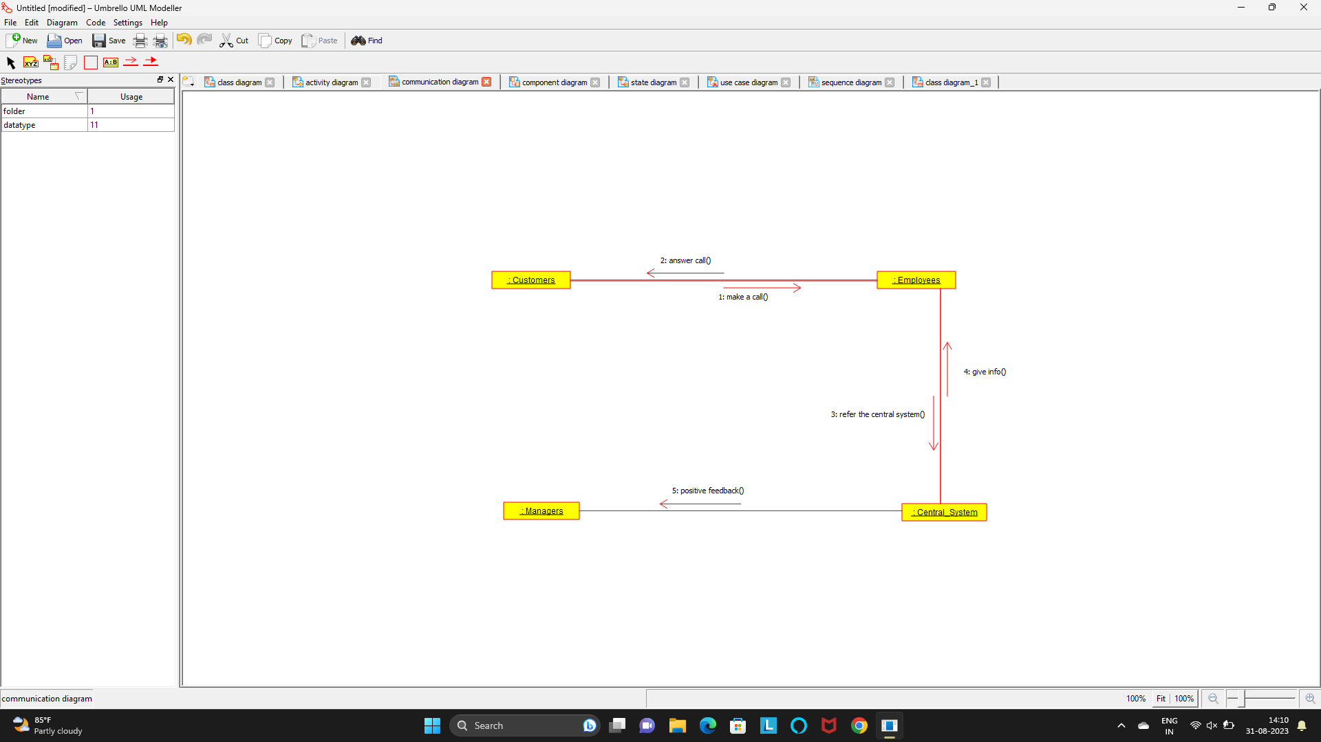

Component Diagram

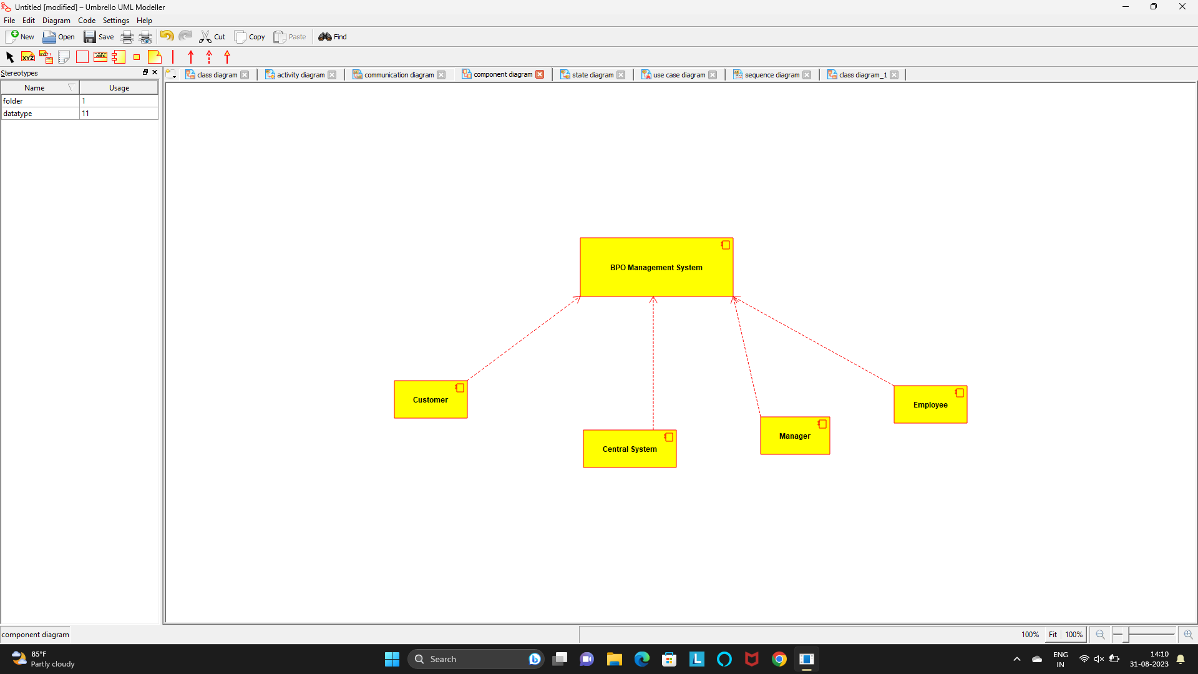

Develop a system using UML for Airplane Reservation System. The customer can search for flights for a given data and source/destination airport and reserve the required seats, the system should handle the payment. The customer can view flight schedules and cancel their reservation(s) if needed. Admin can add new aircraft, flights, and flight schedules. Admin can cancel any prescheduled flight and a notification should be sent to all stakeholders

State Diagram

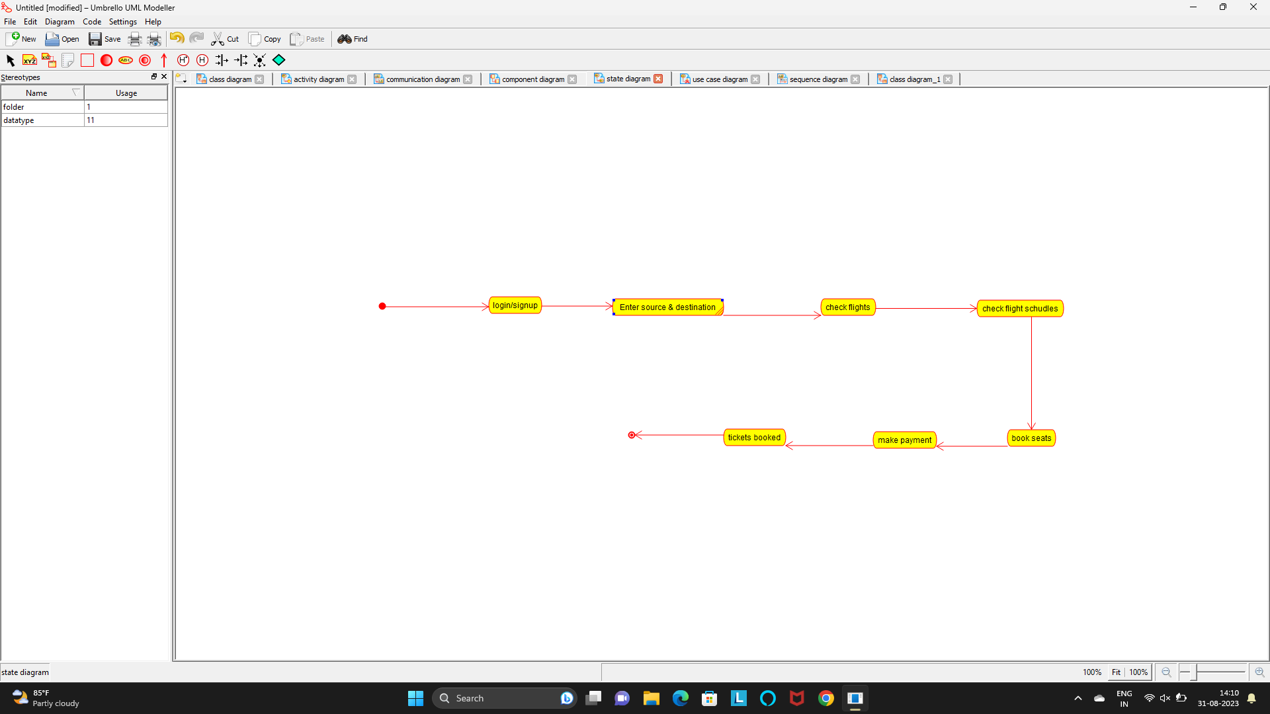

Usecase Diagram

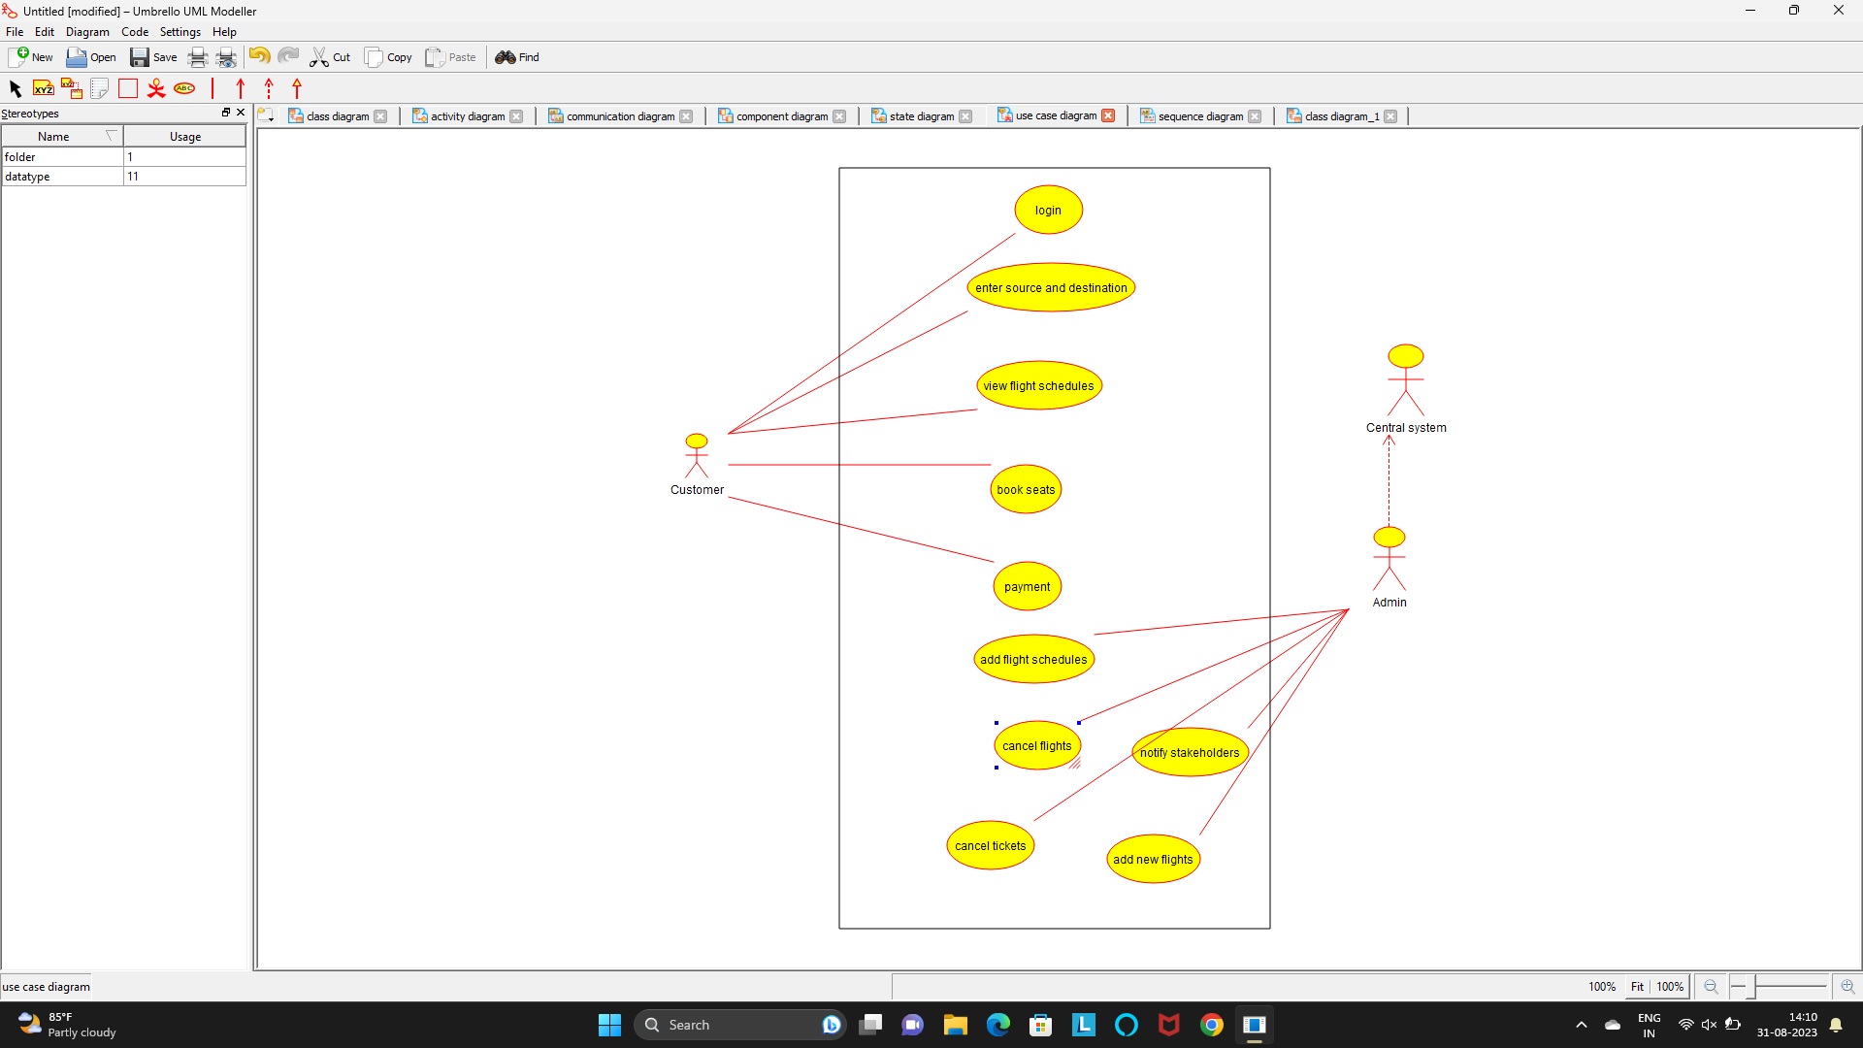

Sequence Diagram

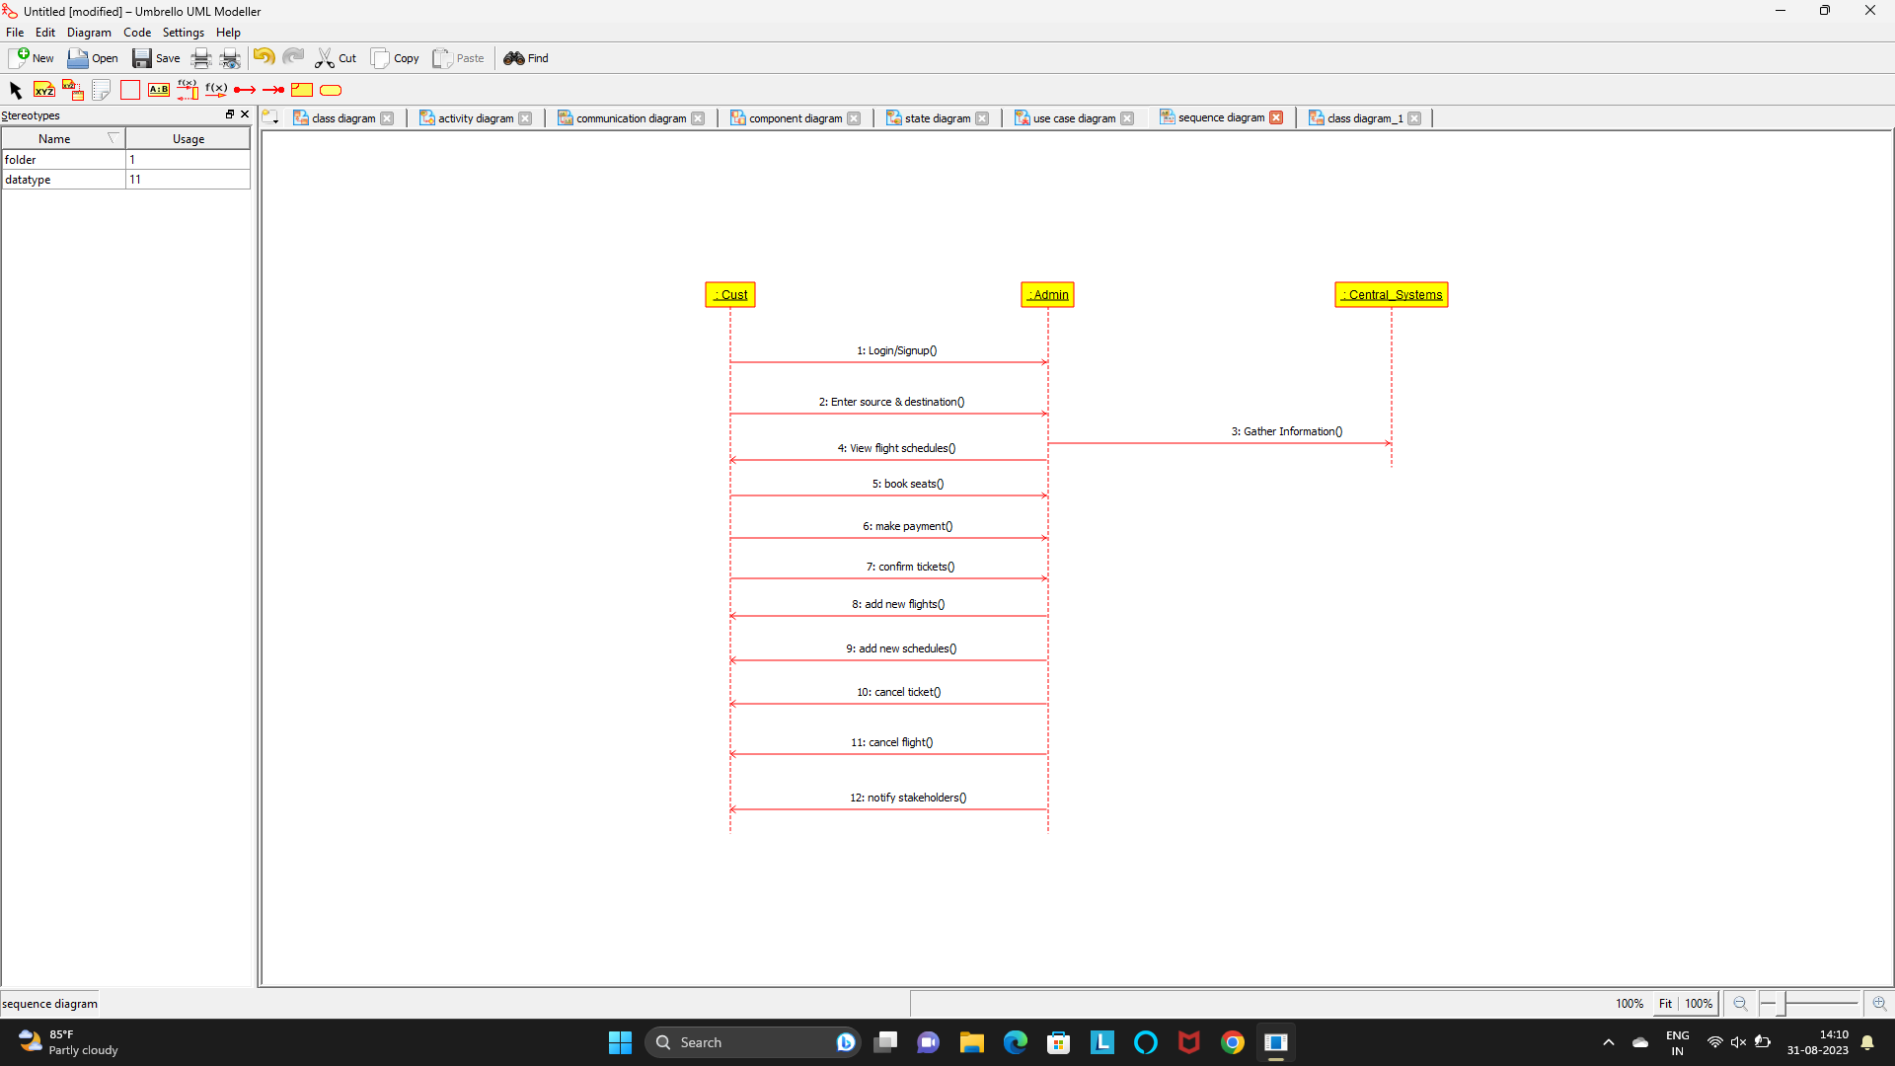

Package Diagram

